Guidance services within the Hungarian compulsory education and VET system

Recent trends and burning issues

Antecedents

Guidance counselling has traditions of long standing in the Hungarian public education system, dating from before the change of the economic and political regime: the national career orientation network was established by Government Decree No. 1029/1971 (VII.3.), in the era of the “existing system of socialism”. It was pursuant to that legal regulation that the National Career Guidance Institution (OPTI) and the National Career Guidance Council (later on: Committee) were set up under the auspices of the Ministry of Labour (MüM). Service delivery was assigned to the county orientation institutions. The system gradually lost its autonomy in the early eighties, and the county institutions merged into the institutes of pedagogy. Schools had to have their own orientation counsellors. Teachers fulfilling that role were exempted from part of their “normal” lessons to do the orientation work. By the time of the change of regime, there existed no independent orientation institution and expert network in Hungary any more.

Given the operating mechanism of the plan economy and the logic of the late industrial society, the system deployed in the seventies did not and could not target lifelong guidance (LLG). Instead, it was put to the service of such clear-cut objectives as the choice of school and vocation and, given its quantitative limits, it reached very few people. The clients of the county institutes were mainly the children of the intellectuals, the members of the urban population.

In the period of the change of regime, in 1988-1993, the orientation tasks have been left without a real owner, and this circumstance has marked the Hungarian system to the present day. The two competent ministries concluded no long-term strategic agreement concerning the deployment, operation and evaluation of the orientation services. The Public Employment Service (PES) instituted by the Employment Act of 1991 initially employed many professionals who had worked in orientation and considered it a personal matter to carry on with their profession and tasks. Later on the labour legislation actually identified career guidance and orientation as functions of the employment service. Time went by, but task division between the sectors of public education, tercier education and labour has never been codified (as opposed to what happened in e.g. Finland, Ireland and Scotland, etc.), and it has retained its ad hoc nature to the present day. The employment service tried to satisfy the relevant school demand mainly through the establishment of the so-called Vocational Guidance Centres (VGCs) (modelled on the German Berufe Information Zentrum system), and the development of the related service contents (films/folders presenting vocations; self-evaluation methods). By the middle of the nineties, the employment service became the biggest employer of practitioners with a degree in career and work guidance acquired at the new college faculties created with World Bank support. The schools, for their part, followed suit a few years later, employing qualified orientation teachers from the second half of the nineties on.

Within the education system, the amendment of the first Public Education Act of 1985 in 1990 opened the way to crushing the previous 8+4 grade system (8-year primary + 4-year secondary school) in public education. The emerging eight- and six-year general secondary schools have got the best part of pupils by now. The transformation of the institution system was concurrent with the multiplication of its maintainers: pursuant to the Municipality Act of 1990, the institutions concerned were transferred to thousands of maintainers (settlements, county municipalities). As for the institution of the school inspectorates, that was terminated in 1987. The institutes of pedagogy were transferred to county maintenance, with an average 1-2 specialised staff left to fulfil the orientation functions. The Budapest Career Guidance Institute was the only county-level orientation institution which survived the change of regime and remained independent from 1988 to 2007.

The new education acts passed after the change of regime were announced in 1993. The public education, vocational training and higher education acts all guarantee the free choice of work and career to pupils and students and to their parents, in accordance with the provisions of the Hungarian Constitution. In practice, however, the orientation possibilities granted under the law often meant no more than a single briefing session.

The first National Core Curriculum (Hungarian abbreviation: NAT) issued in 1995 (restructured in 2003 and in 2007) specified pedagogical development in grades 1-10 in terms of ten cultural domains. One of the ten domains was the teaching of way-of-life and practical skills, including career orientation. The first NAT defined the percentage rate of way-of-life and practical skills to the total curriculum at 4-7% in grades 1-4, 5-9% in grades 5-6, 6-10% in grades 7-8 and finally 5-9% in grades 9-10. Parallel with the release of the core curriculum, the teaching staffs came to face a new challenge: they had to work out the corresponding local curricula. The cultural domain in question integrated three subjects: technology, domestic science and, finally, career orientation.
The system of content regulation
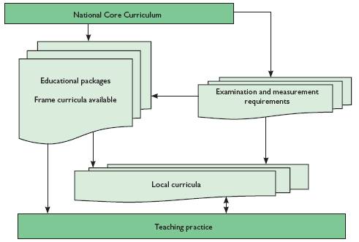

Source: Vass, 2003
The phrase ‘(career) guidance’ in use before the change of regime gave way to ‘(career) orientation’. According to the relevant legislation, its general objective was to help pupils/students choose a career. This included, more specifically, the following components: self-knowledge development based on the identification of the individual’s abilities and skills; experiential familiarisation with the content, requirements and access pathways, possibilities and alternatives of the most important careers, occupational branches; reconciliation of the possibilities with reality, of the aspirations with the realities. Pupils must be made aware of the prospect of repeated career changes during their working life. Schools must provide a comprehensive overview of the world of labour, matching the age of their students and their own possibilities. Consequently, it is necessary to provide for such conditions and activities as may help the pupils test their capabilities and become absorbed in the areas capturing their interest, in order to develop their self-knowledge and career knowledge. Orientation can only be effective if it is implemented over a longer period of time and if it exploits the possibilities inherent in the various subjects, lessons and extracurricular areas and activities in a concerted way. (NAT 1995)
Thus NAT I was sufficiently sensitive to communicating the life-path approach as well as the possibility/necessity of multiple decision-making in the future career of the pupil. Furthermore, from a methodological point of view, it expressed the necessity of cross-curricular development as a way of local community orientation at the schools.
Within the cultural domain of way-of-life and practical skills, the orientation subject include three requirement modules: 1) psychic components of successful orientation; 2.) career knowledge; 3) orientation in the labour market.
The conservative government having won the elections of 1998 inserted so-called framework curricula (1999) between the national core curriculum and the local curricula, on the ground that the preparation of the latter implied an excessive workload for the schools and deepened the gaps between them.
However, given the inadequate personnel conditions, the lack of specialised orientation teachers at the schools and the quite different professional socialisation of a significant part of the active teachers, the orientation lessons were often “grabbed" by the technology teachers who used them, at best, to improve the manual skills and knowledge of materials of the pupils. A major part of the teachers and the school principals regarded orientation integrated into the curriculum as a “luxury service" even at the end of the nineties (Borbély 1999), and/or they simplified its role to decision-making concerning further education, school selection and the filling in of the enrolment forms. The general integration of orientation as a competency area into teacher training has become possible with the launch of compulsory further training for teachers, and with the change-over to the Bologna system and the introduction of the master’s degree in 2006.

Number of students studying in full-time secondary education, according to programme
Academic year | General secondary school l4 grades | General secondary school with 8 and 6 and 4 grades | Vocational secondary school | Vocational training school** | Special vocational training school*** | Total (including junior general secondary school)
1960/61 | 108,258 |  | 47,269 | 136,453 | 737 | 292,717
1970/71 | 122,988 |  | 110,303 | 223,238 | 426 | 456,955
1980/81 | 89,400 |  | 113,838 | 166,740 | 1,119 | 371,097
1990/91 | 123,427 |  | 168,445 | 222,204 | 3,152 | 517,228
1994/95 | 140,352 | 158,957 | 196,965 | 185,751 | 5,546 | 547,219
1999/00 | 145,210 | 175,492 | 241,369 | 117,038 | 4,642 | 538,541
2000/01* | 149,500 | 178,500 | 239,300 | 120,330 | 5,200 | 543,330
2001/02 | 154,383 | 182,267 | 238,622 | 123,951 | 6,594 | 551,434
2002/03 | 158,664 | 186,508 | 239,793 | 123,341 | 7,200 | 556,842
2003/04 | 162,216 | 190,447 | 247,622 | 123,457 | 8,147 | 569,673
2004/05 | 165,182 | 193,366 | 245,302 | 123,403 | 8,369 | 570,440
Source: MoE Statistical Handbook, calculations of Erika Garami, based on the Education Yearbook of 2004/2005
Note: Data include number of students following a special needs curriculum.
* Data for the 2000/2001 academic year are estimates of the Ministry of Education, based on a 98% survey and trends.
** Up to 2000, data for vocational training schools include combined figures for apprentice training schools, typing and shorthand, healthcare and other vocational training schools. In the new statistical system, only vocational training schools are recognised (former specialist vocational training schools no longer exist in their previous form).
*** Special vocational training schools included vocational training schools with a special needs curriculum (and corresponding forms of education) even in periods prior to 2000.
Source: Education in Hungary 2006
As of the academic year of 1998/99, the institution of skilled worker training (apprentice) schools having emerged before the change of regime was terminated. This three-year training programme used to provide an industrial vocational qualification but no GCSE to pupils by the age of 17. Pursuant to the amendment of the Public Education Act in 1996, as of 1998, the age limit of compulsory schooling was raised in a phasing-out system to 18, and vocational training was abolished in grades 1-10. Thanks to the new regulations coming into force in the late nineties, pupils of career-choosing age gained valuable years to make a decision, but under the effect of the modifications, secondary vocational training suffered a further loss of its already shattered prestige. With the postponement of secondary and higher level VET to the ages of 17-22 anyway, college faculties seemed more attractive to most people, especially since the majority acquired a GCSE anyway. In addition, the parents of the career-chooser youth used to be socialised in the seventies and eighties, when the acquisition of any diploma automatically implied an exclusive labour market position given the artificially maintained very limited number of college and university places at that time. The Hungarian labour market is exceptional in Europe in that it marks up its degree-holder career-starters. Pursuant to the changes, vocational school training providing no GCSE was also extended by two years. Significant gaps based on the formal school qualification and results of the youth have become permanent features of the labour market.

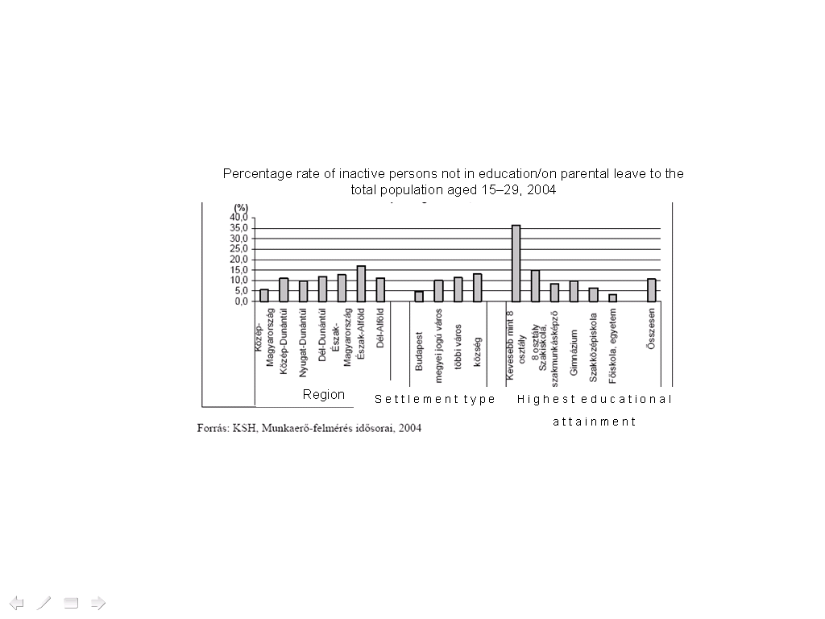
Source: CSO, Labour force survey time series, 2004. (% of ‘NEET’)

In 2003, NAT-2 partly restructured the original NAT, and orientation was transferred from the category of way-of-life and practical skills to that of priority development tasks. Within the cultural domain concerned, the role of preparation for an environment-conscious and successful life, of competence development, value orientation and the development of a way-of-life culture, was enhanced.

Drop-outs per 100 students in vocational, vocational secondary and general secondary schools in
1989–1994

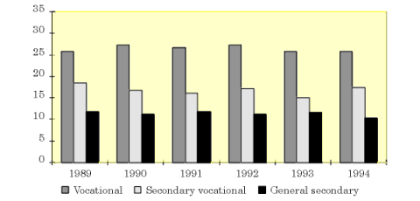

Source: Statistics of the Ministry of Culture and Education, http://www.oki.hu/oldal.php?tipus=cikk&kod=eduhun96-05-student
The scope of orientation as defined in 1995 was extended. A special role was assigned to social adaptation and integration as one of the objectives of orientation, and less emphasis was given to labour market skills, identified as its exclusive domain previously. The emphasis shifted in favour of the development of social and civic, welfare and social competences and skills, flexibility, the management of uncertainty, soft skills and core skills.
In line with the relevant EU objectives (as expressed in the Recommendation of the European Parliament and of the Council of 18 December 2006 on Key Competences for Lifelong Learning (2006/962/EC), the most recent NAT adopted by the Hungarian Government on 31 July 2007 provides for the development of the key competencies, namely
- communication in the mother tongue,
- communication in foreign languages,
- mathematical competence,
- competences in science and technology,
- digital competence,
- learning to learn,
- social and civic competences,
- sense of initiative and entrepreneurship,
- cultural awareness and expression.
Each competency area is followed by a list of the necessary knowledge, skills and attitudes, to facilitate the Hungarian interpretation of the competency and competency development terminology taken over from English. The Hungarian equivalent of ‘empowerment’ interpreted as the product of knowledge transfer and skills development is much closer to the target.
Under the new NAT, orientation is no longer one of the priority development tasks, but its place is taken by several functions including it as a relevant component. However, it is a serious cause of concern whether (career) orientation, having appeared in the Hungarian schools in so many different forms in the past ten years, will be able to hold on in school life, overcrowded anyway, now that its legislative support is lost.
Number of teachers
 | 1990 | 2005 | Change, % | Change
Pre-school | 33635 | 30700 | 91.27 | -2935
Primary school | 90511 | 87116 | 96.25 | -3395
Secondary school | 35733 | 38572 | 107.95 | 2839
Other | 6163 | 1113 | 18.06 | -5050
Total | 166042 | 159506 | 96.06 | -6536
Number of children (thousand)
Pre-school | 392 | 325.9 | 83.14 | -66.1
Primary school | 1167 | 887.8 | 76.08 | -279.2
Secondary school | 514 | 562.3 | 109.40 | 48.3
Other | 39 | 8.4 | 21.54 | -30.6
Total | 2075 | 1784.4 | 86.00 | -290.6
Source: CSO, 2006
For, school practice underwent numerous changes in the past period. On the one hand, the declining number of children raised the problem of superfluous teachers; on the other, in the context of ever keener inter-institutional competition, the value of the school services, including orientation, appreciated. Nevertheless, there is still no accepted general national or at least pedagogical definition of the content of orientation. The new NAT treats this area, too, as a core task to be performed by the teacher (similarly to the teaching of digital literacy, healthy living and environment-consciousness), but a major part of the currently active teachers does not command the necessary technical skills for that. The macro-political documents of the system of public education make it possible to “sensitise” pupils/students to the idea of lifelong guidance (LLG) in the modern sense, but the relevant school and classroom practice is extremely fragmented.
Thus the current institutional structure does not meet the EU and OECD recommendations. The content of the guidance service is not clear; there are no national-level professional standards on orientation and hence it is impossible to observe the service-level-specific recommendations based on the international standards. Neither has the system of pupil portfolios become part of everyday Hungarian teaching/school practice, although some schools profit from the system of mandatory central competency surveys to prepare such documents. Orientation as a human service provided by the school could be made much more effective by an instrument of this kind.
However, in their current state, the EU/OECD recommendations are not mature enough either. EU Resolution 8448/04 EDUC 89 SOC 179 sets clear tasks for every Member States to promote the development of the national and European career guidance systems and hence the deployment of the service-provider economy. The main development direction is to widen access to lifelong guidance concurrent with lifelong learning.
The Union-level decision of 18 May 2004 was built on three pillars:

- adoption of common objectives and guidelines for life-path and career orientation,
- deployment of the quality assurance of the service,
- collection of the main features of the lifelong life-path and career orientation system (best practices, EU-level directives, extension of the open co-ordination method (OMC) to orientation).
Figure 1.
Steps of support intensity and price by EU-OECD standards
Intensive support (by highly skilled professionals) (step 3)
Supported self-information ( step 2)
Independent information acquisition and processing ( step 1)

The current terminology merges everything under the collective concept of ‘guidance’ motivated by pragmatic and functionality considerations. The earlier OECD recommendations, however, distinguish the above three levels to which they assign different authorisation (competencies of the providers) levels and competencies. Orientation, moving about in the domain of pedagogy, will only find its definite place in Hungary if sooner or later specific professional skills and competences can be assigned to the orientation tasks, as it happened in the Canadian or the Irish or Finnish systems. In order to do so, it is to be taken into account that the right kind of support based on the right professional skills is needed at the various decision-making points (cf.: Can/should a subject teacher be sufficiently familiar with the labour market conditions to inform his/her school- leaver pupils about it? Etc.). Furthermore, in the context of development, one must not disregard the limits imposed on the scope of action by the conflicting interests at play, such as the inevitable counter-motivation of a VET institution as far as quality orientation services are concerned (it is no accident that vocational school and TISZK (Regional Integrated Vocational Centre) developments as well as higher education speak of career guidance and career development instead of career orientation; or that multinational companies refuse to let career counsellors enter their premises, but they welcome coaches promising to enhance the performance of their organisation.) The current distinctions of the OECD terminology do not reflect these considerations (cf. career guidance).

Current developments

In the years 2000, several developments took place to provide pupils/students career orientation services. The developments concerned were not without antecedents: the vocational secondary school orientation model as well as a significant part of instruments and protocols in use in the area of labour to the present day have been prepared at the time of the World Bank donations.

The circle of educationally-motivated developments included two important and significant projects in Hungary in the past years.

I. Development of the competency area of career building in grades 1-12

Measure 3.1.1. of the Human Resources Development Operational Programme (Hungarian abbreviation: HEFOP) co-financed by the European Union included curriculum development for grades 1-12 in the competency area called ‘career building’ instead of ‘orientation’. The activity was completed in March 2008. To date, 600 schools and 105 thousand pupils and 8000 teachers take part in the relevant project launched under the management of the former Sulinova Kht. (legal successor: Educatio Kht.). The basis of the professional development was an application entitled Real Game, imported in part earlier from Canada. The career building competency area defined its own guidelines as follows:

Process principle
If the activities representing the life-path are defined as creative activities then, obviously, their series has a chronological dimension and that dimension appears, in the final analysis, as a process over the life-path. In essence, we introduce our pupils to that aspect of the socialisation process which manifests itself in the form of activities. Teachers work with their pupils over a definite time interval, a “frozen moment” (which, however, may be as long as a year). This is a short interval in terms of personality development and self-development. So, they meet in a specific life-cycle stage. This is why the activities representing the point of departure of steps to be defined at a later date must have a process-like character.

Development principle
Both the individual and the pedagogical approach associates change, often defined as a new quality, with the concept of the life-path. Biological development typical in school age actually calls for the association of psychological development. That is, in the context of career building, we must provide for the quality development of the individual personality traits, to contribute thereby to personal development, career building and success.

The principle of periodicity
Periodicity, i.e. repetition, is present in the process of creative activity. The same experiences, events and circumstances will recur, albeit in different qualities. The repetitions may mark strongly interlinked or clearly separated phases. Repetition is an essential component, and it is motivated by the wish to fulfil ever more advanced requirements or objectives.

The principle of consolidation
It is a precondition of the activity that the personality traits ensuring its continuous performance be present. The personality traits concerned consolidate gradually in time, and the activity process, the activity itself is defined or influenced exclusively by the consolidated personality traits.

The principle of taking the positive circumstances into account
Career building puts less emphasis on developing emotionally positive contents, personality traits and knowledge: it focuses instead on highlighting the existing ones. Stressing one’s strengths allows to lay the bases of correct self-evaluation and the right level and quality of self-confidence.

The support principle
Career building is a supportive activity: it implies no direction or the assumption of the responsibilities. Support is provided to help the client select what is best for him/her. This principle implies that one cannot decide for another person; one can only present the possibilities open for choice and make them aware of the possibility of matching the individual traits and the changing opportunities.

The Sulinova development illustrated the pedagogical function of career building with the following chart.

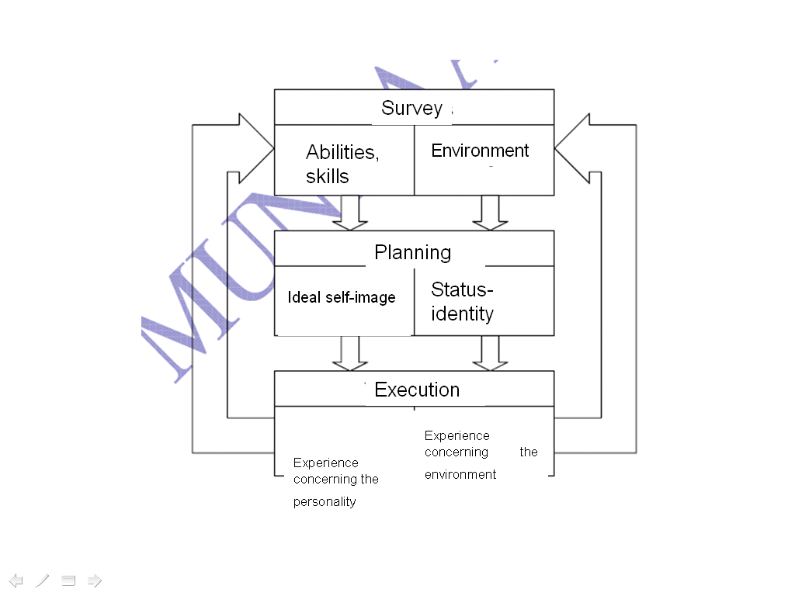

It is a great merit of development related to the competency area of career building that it focused on cross-curricular development and identified the place of career building in the various cultural domains, and produced a syllabus covering the orientation tasks of school teachers in grades 1-12.

II. Vocational School Development Programme, Career Orientation

Parallel with the development implemented with ESF support, the Hungarian Government launched its vocational school development programme. The first and second SZFP (the acronym stands for the Hungarian name of the programme: Szakiskolai Fejlesztési Program) were implemented by the National Institute of Vocational Education (Nemzeti Szakképzési Intézet). 90 trade schools were involved in the first SZFP and 70 additional in the second phase. 100 trade school teachers were trained. At the 9 class in the trade schools according to the current public education law schools could make theirs own decision teaching career orientation 2 classes per a week (74 classes per a school year) or do not teach.

The administration wanted to boost the development of vocational schools brought into a highly disadvantageous position by the extension of compulsory schooling to age 18, described already, with this development project. Within the SZFP, the development of orientation at vocational schools was assigned to Module G. This was worked out with a reduced content ab ovo, given the fact that this type of school provides no maturity certificate for graduating pupils. Consequently, the further education and placement options of pupils having studied there are limited to jobs and further training requiring no GCSE.

Many criticized career orientation development designed for the vocational schools as being a dead end. Nevertheless, as a result of the development project, hundreds of vocational schools and their teaching staffs were provided further training in career orientation. The participating institutions and their teachers established a network. Furthermore, an electronic career guidance package was prepared, which is now accessible on DVD under the title of SzakmaInfo.

III. The role of the PES: PHARE and HEFOP 1.2. developments

Parallel with the developments instituted by the public education administration, the labour administration has also made progress. From May 2004 on, three development projects enjoying PHARE support were implemented under the title ’Transition from training to work’. The three winner regions were the Southern Great Plain, the Northern Great Plain and the Northern Hungarian region, respectively. The developments were implemented by consortia, with the county PES centres acting as consortium leaders in all three regions. As part of the developments, some 100 persons per region were provided further training in orientation in 30-90 lessons, and three career orientation websites were prepared.

After the completion of the development projects, the website “epalya.hu” became the national portal of the Hungarian Public employment Service. The portal will be upgraded to a significant extent, including the introduction of a two-channel (youth, adult) access feature, but this will take place already in the second national development cycle of 2007-2015, under the Social Renewal Operational Programme of the New Hungary Development Plan (Hungarian acronym: ÚMFP TÁMOP).

In the framework of HEFOP Measure 1.2. dedicated to the development of the own organisation of the Public Employment Service, from 2004 to March 2008, more than 374 VGC folders presenting occupations were modernised and new films presenting occupations were made. In addition, information on the current labour market situation and employment prospects was inserted into 212 occupation folders.

Parallel with the new development, PES continues to play a significant role in career orientation in the form of the organisation of the annual county career choice exhibitions, the operation of the VGC offices and the management of pupil/student queries addressed to its work and career counsellors staff, but no progress has been made so far in the informal or contract-based specification of the division of tasks between the PES and the education system.

Summary, tasks ahead

The above makes it clear that, in the years 2000, the Hungarian public education and labour administrations instituted significant developments to strengthen the orientation services provided for pupils. The developments concerned focussed, partly in contrast with the relevant international recommendations, mainly on the teaching staffs. They produced an enormous quantity of new syllabuses, but one wonders whether it will be possible to actually use these at the schools one day, and to provide new and already active teachers the type of continuous training/up-skilling and supervision required for that.

None of the developments took into account the fact that, to date, with the global transformation of the position of the school, the orientation role of the teachers is becoming s negligible in Hungary as elsewhere (see the table below).
Your source of information concerning the chosen career (%)
 | Parents | Saw in his/her environment a | Acquaintance active there | Publication, event | Media | Choices of friends | Teacher
Budapest | 46.3 | 13.7 | 10.5 | 7.3 | 8.4 | 3.2 | 6.4
Countryside town | 43.7 | 23.6 | 11.8 | 8.5 | 8.1 | 4.2 | 0.9
Small settlement | 49.2 | 22.7 | 12.6 | 6.6 | 4.7 | 5.4 | 0.6
Source: Educatio 1998, FPTI research

Thus it is to be feared that part of the instruments developed this way will never reach the circles of users. The sectors of public education and labour have not been harmonised yet either, although the EU Committees on Education and Culture and Employment and Social Affairs strongly urge that through the European Lifelong Guidance Network (ELGPN) set up in 2007. The transforming limits between the labour market and the schools (cf. LLL) question the efficiency of developments implemented strictly within the school system.

Although there are several orientation/career-building syllabuses in use in public education, the relevant methodology, and the scope of authority and competencies of the teachers and other human professionals responsible for implementing them have not been defined yet (contrary to the solutions found e.g. the USA – ACA as private association; Canada - HRDC ministry); there is no professional canon and no written public or professional code of ethics applicable to this area. It will be most important to pay attention to that in the ÚMFT TÁMOP development period in Hungary which belongs to the circle of transition states which can be modernised from above.
Appendix 1
Description of Hungarian education and training programmes according to ISCED-97 classification
Institutional setting of programme | Programme destination and orientation | Notes
Pre-school | 0 | School-based programme for children aged 3-7. Includes basic skills development, pre-reading, drawing, singing and school preparation.
General school | 1AG | General school primary level, Grades 1–4.
 | 2AG | General school lower secondary level, Grades 5–8.
Vocational training school (Apprenticeship training) | 2BG | Remedial programme for drop-outs and low achievers that provides a second chance for further education
Vocational training school (Apprenticeship training) | 2CV | Vocational training school programmes preparing qualifications for trades identified in the National Register of Vocational Qualifications that do not require the completion of 10 years of general education for entry
Vocational training school (Apprenticeship training) | 3CG | Vocational training school, Grades 9–10. General subject courses with vocational guidance preparing students for entering into programmes that require 10 years of general education
Vocational training school (Apprenticeship training) | 3CV | 3-year apprenticeship training programmes according to the Education Act of 1985 starting after grade 8 of the general school. 1997/98 was the last year of new enrolments, because the new law does not allow dual system vocational education before age 16.
Vocational training school (Apprenticeship training) | 4CV | Post-secondary vocational programmes where the entry requirement is the completion of secondary education
Special vocational training school | 2CP | Basic skills and labour market oriented development programme for students with special educational needs
General secondary school | 2AG | Grades 5–8, and 7–8 of the eight-grade and six-grade general secondary school
 | 3AG | General secondary education, grades 9–13 preparing students for secondary school final examination
Vocational secondary school | 3AP | Vocational secondary school programmes preparing students for secondary school final examination with pre-vocational elements, Grades 9–12 (13).
 | 3BP | Vocational secondary part-time programmes, Grades 9–12 (13) preparing for secondary school final examination with pre-vocational programme elements
 | 4AG | General secondary programme preparing for secondary school final examination for vocational training school graduates (3CV)
 | 4CV | Post-secondary vocational programmes where the entry requirement is possesing secondary school-leaving certificate

 | 5B | Non-university higher vocational training programmes leading to non-graduate vocational qualifications with credit courses acknowledged in higher education
College, university | 5A | College graduate education and post-graduate specialisation programmes, University graduate education, University supplementary (Master) programme for college graduates, Supplementary teacher training programme for engineers graduated in college education, University post-graduate specialisation programme for university graduates
University | 6 | PhD courses, research work and dissertation DLA, doctoral degree in liberal arts
Source: Statistical Yearbook of Education 2002/2003, OM, 2003.
Notes: Destination for which the programmes have been designed to prepare students: A=access to further general education, B=access to further vocational education, C=access to the labour market.
Orientation category is based on the degree to which content of programme has been specifically designed:
G=general, P=pre-vocational, V=vocational.

Appendix 2
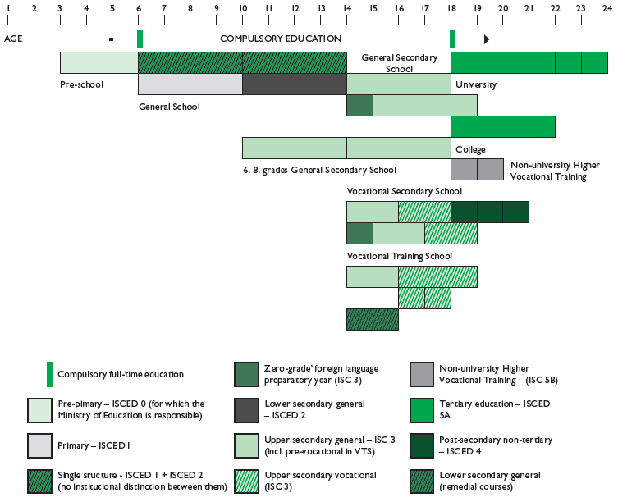

Appendix 3
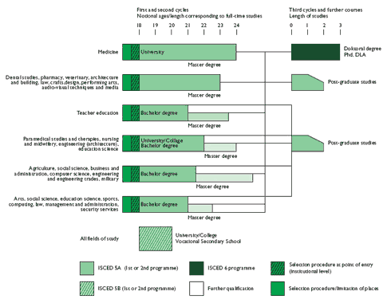

Literature
„Célok, szereplők, módszerek” (Objectives, players, methods), National Career Orientation Conference, Szombathely, 11-12 September 2001.
„Házhoz kell szállítani a pedagógiai szakértelmet” (Door-to-door delivery of pedagogical expertise), Új Pedagógiai Szemle 2000/11 (interview with Júlia Ránki Lantos) http://www.oki.hu/oldal.php?tipus=cikk&kod=2000-11-mh-foldes-hazhoz
Gov. Decree No. 1057/2005. (V.31.) Korm. On the implementation of the vocational training development strategy
Gov.. Order No. 202/2007 (VII.31.) Korm. on the amendment of Gov. Order No243/2003. (XII.17.) Korm. on the publication, introduction and application of the national core curriculum
Act CXXXIX of 2005 on higher education, 2008.
NAT 1995 / Életvitel és gyakorlati ismeretek (Way-of-life and practical skills)
A NAT-2 discussion material, ME, spring 2003
Endre Barkó Pál- Völgyesy - Klára Szilágyi: Pályát választok (I choose a career), Calibra 1997
Tibor Bors Borbély: A pályaorientáció megítélése a tanári közösségekben (Judgement on career orientation in teacher communities), Eger, 1999
Epálya www.epalya.hu
Péter Friss: A nagy kihívás: hogyan teljesíthető a 18 éves korig tartó tankötelezettség (The big challenge: How can compulsory schooling until the age of 18 be realised?), OKI 2005 conf. http://www.oki.hu/oldal.php?tipus=cikk&kod=oek2005-friss
Erzsébet Fürst Kólyi - Endre Sipos: Hogyan tanuljak, hogy legyek valaki? (How should I learn to become somebody?), Fürst Stúdió 1996
Károly Gönczi: Életpályaépítés (Career-building), Pedellus 2006
Gábor Halász –Judit Lannert (ed.) Education in Hungary OKI 2003
Gábor Halász –Judit Lannert (ed.) Jelentés a magyar közoktatásról (Report on Hungarian public education), 2006 OKI
http://www.oki.hu/oldal.php?tipus=kiadvany&kod=eduhun2006
Anna Imre – Györgyi Zoltán (Judit Kaszás): Az oktatási rendszer és a tanulói továbbhaladás (The education system and the pupils’ progress), in: Gábor Halász –Judit Lannert (ed.): Jelentés a magyar közoktatásról 2006 OKI
Kompetencia alapú programfejlesztés (Competency-based programme development), Szakoktatás, No. 2007/4. (interview with Károly Pála)
Csilla Mile - Mátyás Hinek - Judit Torgyik: A karrier irodák lehetőségei a fiatal diplomások elhelyezkedésének megkönnyítésében (The possibilities of ‘career offices’ to facilitate the placement of young degree-holders), Munkaügyi Szemle, Nos 2007/7-8, pp.18-24.
József Nagy: A Térségi Integrált Szakképző Központban végzett képzés lehetséges rendszere és hatékony pedagógiája (Possible system and efficient pedagogy of training at the TISZK), 2006
Pályakövetés magyar módra (Career follow-up à la Hongroise), HVG Trend
Pályaorientáció, új törekvések (Career orientation: new strivings), National Methodological Conference, Gödöllő, 4-5 June 2002.
Pályaválasztás (Orientation), Educatio, thematic number, autumn 1998
Tamás Püski: Középiskolások karrierképei (Career images of secondary-school pupils), Új Pedagógiai Szemle, OKI February 2007.
Piroska Semperger:Pályaorientáció 7-8. évfolyamban (Orientation in grades 7-8), Ráció Könyvek MK1997
Csaba Stausz: A pályaválasztó (The career chooser) – reports, 2003
Klára Szilágyi: A pályák világa (The world of careers), Kollégium Kft. 1997
Klára Szilágyi: A tanácsadó tanár módszertani lehetőségei az iskolában (Methodological possibilities available to the counselling teacher), Eger 1996
Etelka Tóth: Életpálya-építés (Career building), Szakoktatás, No. 2007/5, pp. 1-5. (interview with László Farkas)
Loboda Zoltán, Judit Lannert and Gábor Halász Education in Hungary 2006 Hungarian Institute for Educational Research and Development Budapest, 2007
http://www.oki.hu/oldal.php?tipus=kiadvany&kod=Education2003
YOUTH ON THE LABOUR MARKET Ad hoc module of Labour Force Survey in Quarter IV, 2004 HCSO
Éva Berde - Judit Lannert - Márta Sum Galambos - Dr. György Szenes - Dr. Klára Szilágy: ÉLETPÁLYA-ÉPÍTÉS KOMPETENCIATERÜLET SZAKMAI KONCEPCIÓ (CAREER BUILDING COMPETENCY AREA, PROFESSIONAL CONCEPT), 21 January 2005, Sulinova- HEFOP

OECD Career guidance A Handbook for policymakers 2004 and Improving Lifelong Guidance policies and system CEDEFOP 2005 Using common European reference tools
http://www.sulinovadatbank.hu/index.php?akt_menu=258
http://206.191.51.163/blueprint/_indexDisplay.cfm/lang/1/keyType/content/key/231
Éva Berde - Judit Lannert - Márta Sum Galambos - Dr. György Szenes - Dr. Klára Szilágy: ÉLETPÁLYA-ÉPÍTÉS KOMPETENCIATERÜLET SZAKMAI KONCEPCIÓ (CAREER BUILDING COMPETENCY AREA, PROFESSIONAL CONCEPT), 21 January 2005, Sulinova- HEFOP)
www.szakma.hu
www.epalya.hu www.palyatars.hu www.palyainfo.hu

