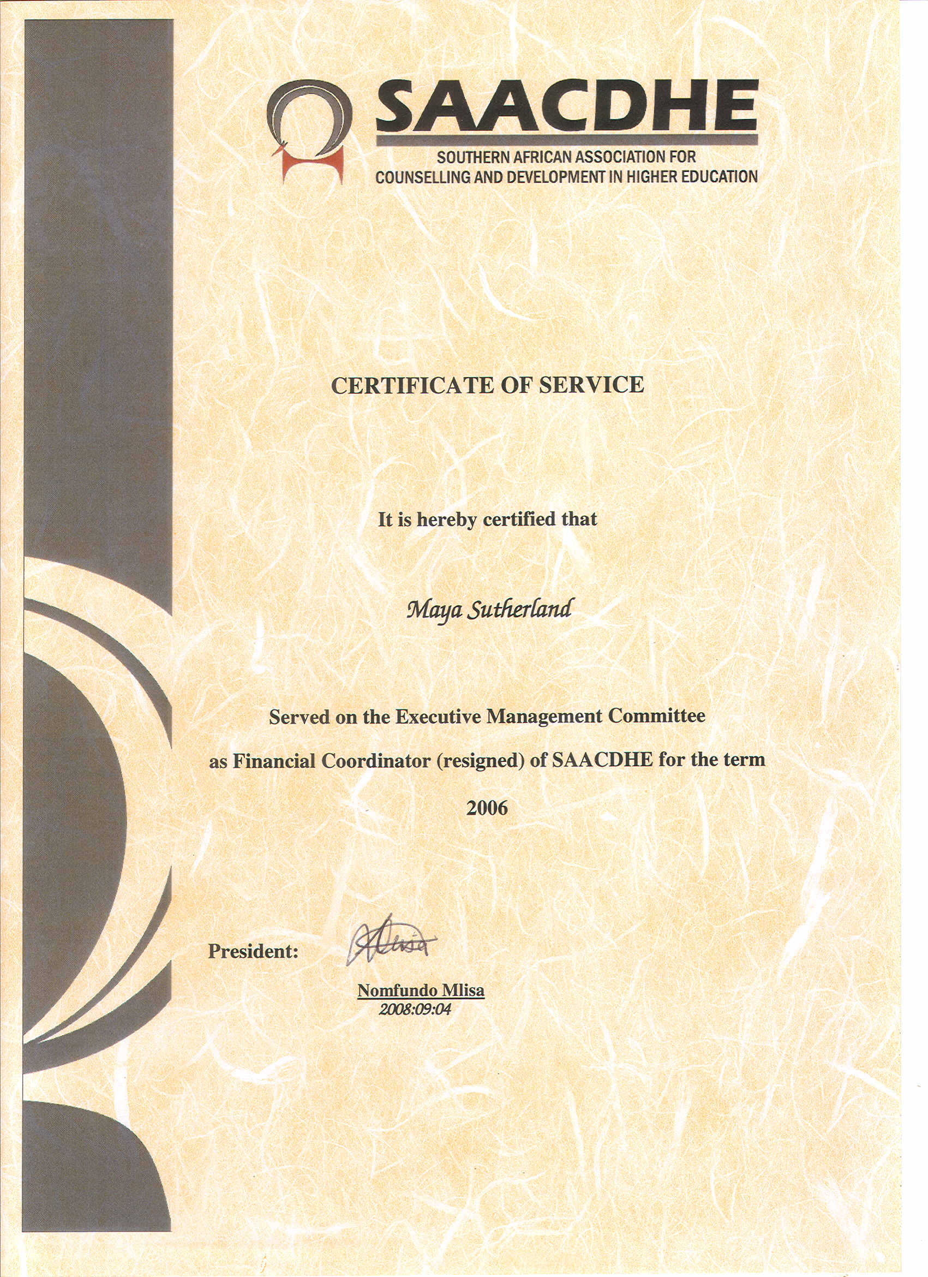

Newsletter

Volume 8 Issue 4

November 2008
Website: www.sscsa.org.za

Southern African Association for Counselling and Development in Higher Education (SAACDHE)

CONTENTS PAGES

EDITORIAL 2

MESSAGE FROM THE PRESIDENT 3

GUEST COLUMN
Dr Ravindra Naidoo 4

EMC NEWS 7

SAACDHE CONFERENCE 2009 8

NEWS FROM THE REGIONS
KwaZulu-Natal Region 8
Western Cape Region 14

TRAINING FORUM: CPD 17

THIS AND THAT: STAFF NEWS 18

EMC AND GMC DETAILS for 2008/2009 19

ADDENDUMS: 20
Membership Invoice, Fee Scale and Application Form

EDITORIAL

The SAACDHE commemorates its 30th birthday this year. *The association was initially established as the Society for University Student Counselling in Southern Africa on 28 November 1978 and has subsequently had two name changes. The first was when the old Technikons were admitted as members of the society in 1980 and the name changed to the Society for Student Counselling in Southern Africa (SSCSA). This is the name that we have all become familiar with. The second name change happened in 2007, when it became the Southern African Association for Counselling and Development in Higher Education (SAACDHE). This last name change was in response to the changes in higher education where institutions were merged and units reconfigured. The association is busy changing with the times and moving towards the accommodation of other disciplines, besides psychologists, into the association to make it more inclusive.

This is the first time that the new logo of the SAACDHE appears in the Newsletter after being presented to the members at the recent AGM. It is fitting that the association has launched its new logo to fit with its new name in the 30th year of its existence.

Rhodes University was represented at the founders’ meeting by Mr Mervyn Wetmore as Student Advisor. He will retire as Head of the Career Centre at Rhodes at the end of 2008 after also spending a number of years as the Director of the Careers Advisory Service at UCT.

*I would like to acknowledge Andre de Jager from NMMU as the source of this information, which he obtained from the archives as part of his research for a book on the SAACDHE. I would also like to invite other members to share their experiences or photos of those times with the readers by sending it to the editor.

Our guest writer for this issue is Dr Ravi Naidoo who presents his views on the interesting topic "Collaboration between Student Counselling and African traditional healthcare services at tertiary institutions”

As usual the regions and institutions also share their training and staff news with the readers. Enjoy the rest period!

Abie de Villiers
EDITOR

MESSAGE FROM THE PRESIDENT

Having freshly come from the EMC/GMC meeting from 19 to 21 November 2008 at the UJ Island, my lasting impression is, judging from the enthusiasm, energy, commitment and passion with which the members approach their mandates that the future of the Association is in good hands. I am duly impressed with what is being planned in the various regions, the new life that has been blown into less active regions and the vast array of topics and areas of interest that will be covered in the regions. Thank you guys for the excellent work.

The new members of EMC/GMC were properly inducted, having had to do the ferry crossing to the Island in torrential rains with a pilot with very little sympathy. Even though they were totally drenched, their spirits were not dampened. Unfortunately some established members had to suffer the ordeal with the inductees. These members have physically proved that they can weather the storms of life. Luckily, none was any worse off for wear and tear and the adventure just added to the good spirits.

The planning for Conference 2009 is well underway and Botswana is truly planning another benchmark for the Association. The first call for papers will be going out very shortly. Keba and your team, keep up the good work!

Apart from my normal tasks according to the task description of the President, I have inter alia set for myself and have received the blessings of the EMC for the following strategic priorities:
- To firmly establish relations with the DoE;
- To enhance and cement the relations with HESA;
- To work towards the establishment of formal relations with international sister bodies;
- To interact with the HPCSA, SACSSP and other relevant professional Boards to ensure improved service delivery to our members and the Association in general, and;
- To establish a SAACDHE register of CPD activities as a separate record of such activities augmenting the HPCSA system.

I will endeavour to keep the membership informed of progress.

2008 is not just fading away or petering out; it is rushing towards its conclusion. After a long and tiring year, most of us are struggling just to keep up. Keep heart though, the well deserved break is in sight.

May you all benefit fully from that break. Come back safely and well rested, full of energy and ready to meet 2009 running. I trust that you will enjoy your holidays and reaffirm your ties with family and friends, replenishing mind, body and soul.

May you experience all the blessings of the festive season, and may the sun shine brightly when you walk into the new-year.

“God be with you till we meet again;
By His counsels guide, uphold you,
With His sheep securely fold you;
God be with you till we meet again.”

Harm Stavast
President

GUEST COLUMN

COLLABORATION BETWEEN STUDENT COUNSELLING AND AFRICAN TRADITIONAL HEALTHCARE SERVICES AT TERTIARY INSTITUTIONS

Dr Ravindra Naidoo
University of KwaZulu-Natal, Howard College
naidoorn@ukzn.ac.za

The introduction of an African Traditional Healthcare Service (ATHS) in 2007 at the Howard College Campus of the University of KwaZulu-Natal is indeed a brave step forward with regard to mainstreaming traditional healthcare and alternative healthcare in general. Initiatives of this nature provide us student counselors, as well as fellow healthcare providers, with strategic opportunities to translate models of collaboration among healthcare systems, especially traditional healthcare, into practice.

The ATHS at UKZN has noteworthy basic infrastructure (consultation facilities, recording of confidential information and protocols for professional reporting and referrals) that has been established. Close monitoring, research and attention to professionalisation are now critical for the integration of this service into the university community. The student response on the whole appears very positive. Staff skepticism does exist. With regard to delivery of the service, the evidence suggests the presence of understandable territoriality on the part of the promoters of the initiative. Clearly trust in allies of the initiative such as Student Counselling needs to be established.

Irrespective of the politics that currently prevail counselors need to diligently address the following collaboration challenges identified by Naidoo (2006):
- Acquisition of a sound knowledge base around traditional healthcare in terms of diagnostic categories, modes of intervention, types of healers, and traditional understandings of culture-specific presentations.
- Incorporation and extension of western psychological conceptualizations to be inclusive of cultural understandings
- Development of a collaborative model for culturally safe psychological practice. A culturally-safe practice is one in which the client experiences healing practitioners as complementing each other and a sense of inclusivity in the management of his / her condition ( Ramsden,2002).

Counselling Centres need to make provisions to equip and support Counselling Staff to meet the above challenges. Meaningful engagement with these challenges will ensure that the Counsellor’s diagnostics, therapy and advocacy will be culturally inclusive. The conceptualization of Naidoo et al (2006) of Culturally Unique and Uniquely Interpreted Syndromes needs to be promoted within the discipline of Student Counselling, the ATHS and among students and staff. It is within this conceptualisation that meaningful collaboration is possible between counselors and the Sangoma and it is within this conceptualization that students can appreciate the need for holistic healthcare. The following is a brief summary of this conceptual model :

Culturally Unique and Uniquely Interpreted Syndrome Conceptualisations
While some Culture-Bound Syndromes are unique to the abaNguni, most phenomenologically present as psychiatric disorders, psychological disorders, physical disorders and social deviances and are uniquely interpreted in terms of abaNguni understandings of reality. A unique syndrome such as Ukuthwasa (a calling to train as a Sangoma) cannot be treated using a biomedical approach. A uniquely interpreted syndrome on the other hand, such as Umeqo (a physical affliction of usually a limb caused by stepping on harmful traditional preparations (imithi)), can be treated using western interventions and abaNguni interventions.

It may be difficult at this stage of our knowledge to strictly differentiate between unique syndromes and uniquely interpreted syndromes. Such differentiation must await the gathering of evidence about which conditions are problematic for the allopathic and the traditional practitioner. In the meanwhile, recognizing the need for such differentiation, both practitioners must cross-refer and work together on cases that are problematic using one or the other approach. Clearly such co-operation will demand that practitioners are educated in each other’s understandings of debilitating conditions.

Uniquely Interpreted Syndromes are perhaps easier to identify for a start as they phenomenologically present as psychiatric disorders and have clearly identifiable associated psychosocial stressors. Phenomenologically psychiatric disorders such as Conduct Disorder, Child Abuse and Depression are explained by Psychiatry and Psychology as having psychosocial aetiology while indigenous knowledge attributes these presentations to :

- Ancestors needing imithi to resolve their misery. A human being is targeted to take the imithi on behalf of an ancestor.
- Dissatisfaction of ancestors as a result of not being acknowledged when significant milestones are achieved in a person’s life.
- Dissatisfaction of ancestors when their requests have not been responded to by the one who has a close bond with a particular ancestor.
- Practice of ukuthakatha (use of harmful traditional preparations to cause illness and disharmony).
- Practitioners of ukuthakatha influencing ancestors not to protect a given individual or family.

In cases where psychosocial concomitants exist, often a combination of psychiatric and traditional healing may be the treatment of choice. This is likely to be especially true where the abaNguni patient and his/her family can see a clear association between the psychiatric presentation and psychosocial stressors. The combined effect is likely to enhance overall compliance in both modalities of healing as such an approach allows for shared understanding of the presentation by the patient and practitioners of both modalities. For such a partnership to be successful the central prerequisite is a mutual, genuine embracing of each other’s explanatory models. Ramsden (2002) refers to this type of practice as ‘culturally-safe practice.

How could counselors integrate cultural conceptualizations in their frame of understanding of their clients?

To effectively refer clients to a traditional healer, counselors need to meaningfully probe the ‘traditional’ reality of their clients. Such probing will help to flag the need for traditional intervention in the diagnostic/explorative phase of our work with our clients. I propose that at intake we engage in the following cultural assessment, especially with clients from African cultures:
The assessment may be preambled by a statement such as : For me to understand you holistically, I need to ask some questions about your cultural and spiritual life.
- Probe affiliation to cultural beliefs
  - Does your family or your relatives conduct sacrifices of animal life (umcimbi)?
  - If ‘yes’, tell me about this.
- When you were growing up, did your family host any special function for you at any time as in your pre-primary or high school phases? This will lead you into conversations about rites of passage – their practice and omissions.
  - Did you participate in such an occasion for any relative?
- Tell me about your dreams and what you think they mean. Here you would be looking out for ‘communicative’ dreams which make reference to ancestors and predictions.
- Probe reflexes and natural signs. Have you experienced ‘shivers down your spine’ and ‘your hair standing on ends’? Have you seen snakes and other animals and felt something odd about seeing them?
- Have you been visited by a stranger or have you met a stranger who has told you things about yourself or your family without your asking for such information.
- If your family does not believe in ancestors, what stops them from doing so?
- What is your personal leaning towards recognition of your ancestors?
- Do you know of family/friends who have visited a Sangoma or Inyanga?
- Have you consulted these healers at ay time?
- What transpired when either your family, friends, or you consulted a traditional healer?
- Do you think your symptoms are the result of ancestoral displeasure or ukuthakathi?
- Would you be comfortable with a treatment schedule that looks at your condition from both a traditional and scientific perspective?
This type of assessment helps break the silence around non-western realities and facilitates early referral to Traditional Healthcare. It should be noted that this assessment assumes a fair level cultural knowledge on the part of he counselor. My E-book, Towards Culture-sensitive Healthcare : The Case of the abaNguni, which can be accessed at www.ukzn.ac.za/scc, would be an invaluable reference for such an assessment.

A closing remark I would like to leave the reader with is that relative to the fields of psychology as a whole and medicine, student counselling, due to its proactive orientation is way ahead of the pack in area of collaboration with African Traditional Healthcare.

REFERENCES
Naidoo, L R. (2006). Mainstreaming previously marginalized traditional healthcare practices within tertiary educational institutions. Paper presented at the 27th Annual Conference of the Society for Student Counselling in Southern Africa : Mpekwini.

Naidoo, L R, Sehoto, S & De Villiers, L. (2006). Towards Culture-Sensitive Healthcare : The case of AbaNguni. Available at : http://www.ukzn.ac.za/scc

Ramsden, I M. (2002). Cultural safety and nursing education in Aotearoa and Te Waipounamu. Doctor of Philosophy thesis, University of Victoria, Wellington, New Zealand.

EXECUTIVE MANAGEMENT COMMITTEE (EMC) NEWS

- Elmarie van der Walt (a previous President of the association and presently the Chairperson of the Western Cape region) has informed us that the contact person for the archiving of SAACDHE material at the UNISA library is Marie Coetzee (Archives – Special Collections, UNISA Library in Pretoria). Her e-mail address is: coetzma@unisa.ac.za

- The EMC would like to obtain the names of honorary members of SAACDHE. Anybody with information on names, please forward it to Abie de Villiers (devilliersab@cput.ac.za).

- The profit from the SAACDHE conference held in KwaZulu-Natal in September 2008 is over R100 000 (un-audited report). Congratulations to Saloschini Pillay and her team!

- The EMC and GMC had a successful strategic planning and induction session on the UJ Island from 19 to 21 November 2008.

- The SAACDHE Financial Statements for the year ended 31 July 2008 is available on the web.

SAACDHE CONFERENCE 2008

The 30th Annual SAACDHE Conference will take place in Gaborone in Botswana in September 2009. The theme is “Coming together: A framework for growing individuals and building nations” and the organizers are hard at work with the arrangements. Contact the conference coordinator, Ms Keba Mophuting, at mophutik@mopipi.ub.bw for more details.

News from the Regions

KwaZulu-Natal Region

Nick Munro Fazila Padayachee
Chairperson Administrative Coordinator

1. INTRODUCTION

The KZN Region presents its activities and highlights for the period June - November 2008.

2. REGIONAL MEETINGS

  - 2nd Regional meeting held on Thursday 14th August 2008
  - 3rd Regional meeting held on Wednesday 5th November 2008

3. REGIONAL WORKSHOPS

Second regional workshop: 5 November 2008 (09h00 – 12h30)
Breath Psychology: Its basic tenets and applications in Counselling tertiary level students

Professor Steve Edwards is an Emeritus Professor and Research Fellow in the Psychology Department at the University of Zululand, and was a keynote speaker and workshop facilitator at the annual SAACDHE conference held in KwaZulu-Natal in September 2008. His popular and highly evaluated workshop at the annual conference was oversubscribed, and he was therefore invited to facilitate this workshop to KZN SAACDHE members who were unable to attend the workshop at the conference.

The breath psychology workshop was highly experiential, covering aspects of the psychology of breathing. Five breathing interventions were taught, with a focus on how these could then be taught to students in the context of counselling or group based development initiatives. The five skills included i) ordinary, relaxed diaphragmatic breathing, ii) arousal control, iii) use of locks and circular breathing, iv) breathing with imagery, and v) breath coordinated movement.

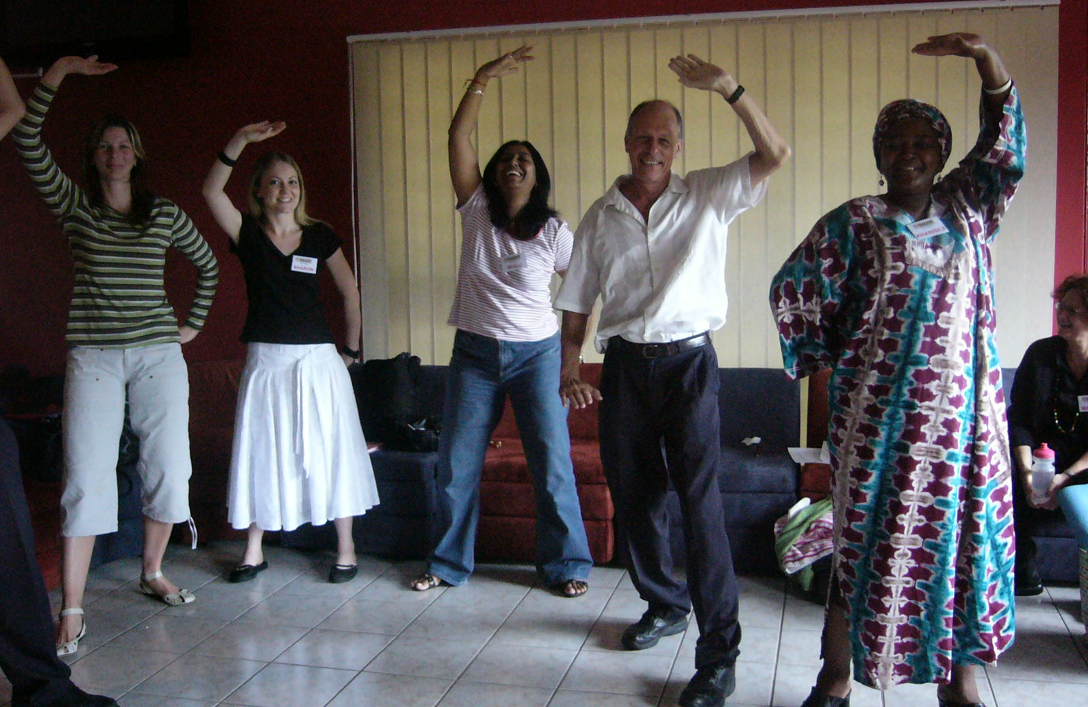

Professor Steve Edwards (second from right) and some of the workshop participants practicing one of the techniques associated with breath coordinated movement

In evaluating the workshop according to its relevance, depth and thoroughness, style of presentation, and audience participation and response, most respondents rated these as very good or good. Many participants requested a follow up workshop with Professor Edwards where more specific techniques could be learned in relation to the student counselling and development context.

4. NEWS FROM REGIONAL INSTITUTIONS

29th Annual SAACDHE Conference: Sibaya Casino (KZN) – UKZN Scoops 3 out of 4 national
awards at the 29th annual SAACDHE Conference

The Southern African Association for Counselling and Development in Higher Education [SAACDHE] held its 29th Annual Conference from 1 to 4 September 2008 at the Sibaya Casino and Entertainment Kingdom. The conference theme “Meeting Today’s Challenges: Enhancing Wellness in Higher Education”, was identified as it has become increasingly evident to Counsellors in Higher Education that students and staff face significant challenges in ensuring that the National Plan for Higher Education is achieved. The conference aimed to unpack these challenges as well as identify key intervention strategies around these issues. Conference hosts, SAACDHE KwaZulu-Natal Region comprised membership from the University of KwaZulu-Natal, Durban University of Technology, UNISA, Mangosutho Technikon and the University of Zululand.

SAACDHE represents the interests of the organized student counselling and development profession in Southern Africa. The Association (established in 1978) was created as a platform for student counsellors of whom many are professional psychologists and social workers from tertiary institutions in Southern Africa, including Botswana, Mozambique, Swaziland, Lesotho and Namibia. It also serves to ensure the highest level of professionalism and international benchmarking in these very important support units in tertiary institutions. Higher Education institutions are faced with the serious challenge of retention and throughput and the resultant impact on DOE subsidy. Student Counselling staff with their unique roles and competencies provide the necessary extra curricular professional support to ensure that students enjoy a positive and successful tertiary experience from registration to graduation. The core function of Student Counseling Centres is career and personal counselling, lifeskills training, personal development and preparing students for their successful entry into the world of work.

The 2008 SAACDHE conference provided a forum where key players discussed the latest developments in counselling and psychology issues, exploring relevant case studies and sharing research based as well as other relevant information and skills among its members. The conference provided hands on learning and the opportunity to network and discuss critical challenges, including insightful key note speakers, such as Professor Hugh Africa of the HEQC, Professor Steve Edwards of the University of Zululand and Professor Sabiha Essack, Dean of the Faculty of Health Sciences from the University of KwaZulu-Natal.

Conference Chair, Mrs Saloschini Pillay, the Director of the Centres for Student Counselling, Westville and Edgewood campuses noted that the conference boasted an attendance of 140 delegates from within South Africa and as far as Malawi, Lesotho, Swaziland, Zimbabwe, Botswana, Ghana and Australia. UKZN, in particular is proud of the achievements of its staff with a total of 13 presentations by staff from Student Counselling Centres and the Faculty of Health Sciences.

We are particularly proud that Student Counselling staff of UKZN scooped 3 out of the 4 annual conference awards, in the categories of Best Research Paper which went to Mr Nicholas Munro, Senior Student Counsellor, Pietermaritzburg Campus, for his paper on "Food Insecurity amongst University Students", the award for the category of Best Conceptual Paper went to Mrs Paulette Naidoo, Student Counsellor, Westville Campus and Mrs Wulli Thaver, Lifeskills Officer, Westville Campus, for their paper on the "The integration of lifeskills training as a compulsory credit-bearing module into the mainstream academic curriculum: a conceptual paper on the process of implementation and evaluative outcomes with respect to students’ perceptions of the programme”, the award for the category of Best Poster was awarded to Ms Sharon Draper and Mrs Dita Bosman, both Intern Psychologists at Student Counselling, Westville Campus for their poster entitled “Road to a Better Future Through an Informed Career Decision”. Our awardees, all new and young researchers competed with established researchers and authors of several publications. SAACDHE-KZN Region also received the "Best Region" award for its successful efforts at developing its regional membership and the Association as a whole.

Dr Ravi Naidoo, Director of the Centres for Student Counselling, Howard College and Medical School Campuses, received the "Distinguished Service' award for his contribution to the Association over the past 21 years. Mrs Saloshini Pillay, the 2008 Conference Chair is the new President Elect of SAACDHE. An overall evaluation of the conference by delegates revealed an overwhelmingly positive response to the organization and quality of the conference presentations. The Conference Organizing Committee extends their sincere appreciation and thanks to Mr Trevor Wills, Executive Dean of Students and Professor Dasarath Chetty, Pro-Vice Chancellor Corporate Relations for their unwavering support.

Members of the Kwa-Zulu Natal region received the following awards at the conference:
SAACDHE Distinguished Service Awardee Dr. Ravi Naidoo
Best Research Paper recipient Nick Munro
Paulette Naidoo and Wulli Thaver were the winners of the Best Conceptual Paper Award
Dita Bosman and Sharon Draper were winners of the Best Poster Award

Supported Education for People with Psychiatric Disabilities

The UKZN Centres for Student Counselling and the Faculty of Health Sciences, School of Nursing jointly hosted a workshop entitled “Supported Education for People with Psychiatric Disabilities”, on 6 November 2008 at the UKZN Westville Campus.

Dr. Lies Korevaar is a Professor of Rehabilitation at Hanze University Groningen in The Netherlands. His area of specialization is in the area of Supported Education for people with psychiatric disabilities. The Executive Dean of Students, Mr Trevor Wills at UKZN has been liaising with Dr. Korevaar for a while now regarding this specialized service of supported education, and subsequently invited Dr. Korevaar to present his work at UKZN. The workshop was open to non Counselling members as well, given the multidisciplinary approach required when dealing with people with psychiatric disabilities in the higher education environment. The workshop introduced participants to the Supported Education unit for people with Psychiatric Disabilities at Hanze University in The Netherlands. An interactive and exercise based programme was used to encourage participants to critically think about psychiatric disability in the South African context, and to initiate plans to mobilize a supported education response to this issue in KZN tertiary education institutions.

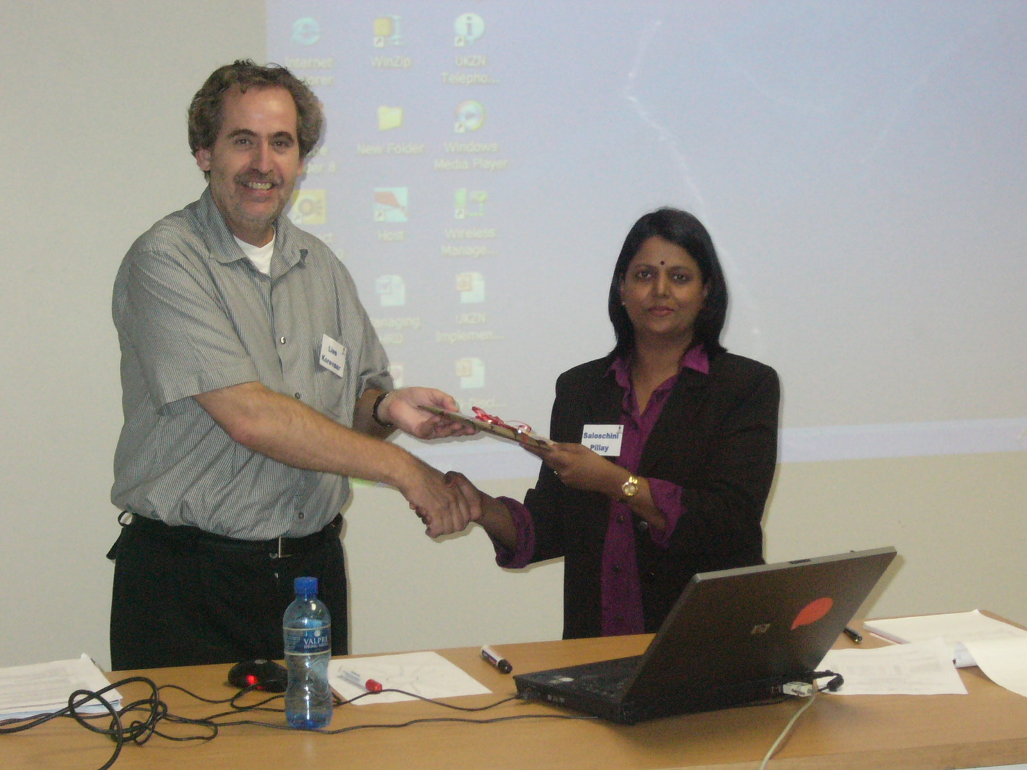
Workshop participants (below) and Dr. Lies Korevaar with Saloschini Pillay (right)
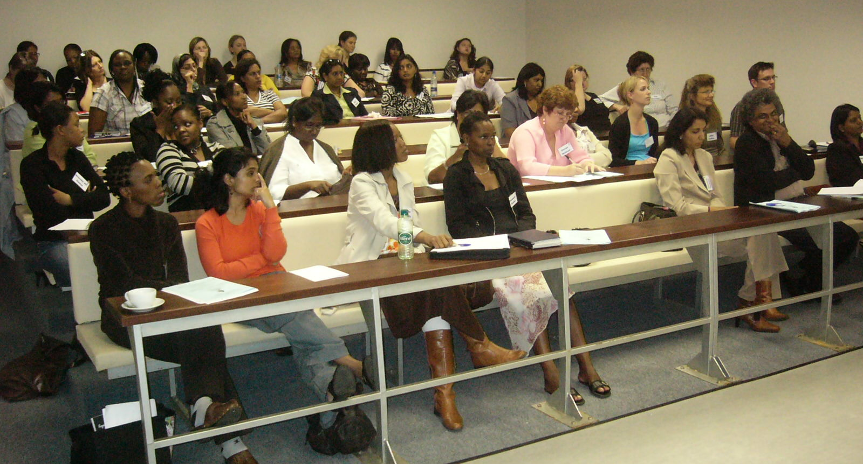

Evaluations of the workshop according to relevance, depth and thoroughness, style of presentation, and audience participation and response, revealed a predominantly “very good” or “good” response.

UKZN Edgewood Campus

“Inclusive Education, Assessment Guidelines and Teaching Strategies for Students with Visual Impairment”

The above workshop was hosted by the Disability Support Unit of the UKZN Edgewood Campus on 21 August 2008. The aim of the workshop was to create awareness on visual impairment with a specific focus on inclusive education, assessment guidelines and teaching strategies. A total of 13 participants attended, comprising academic staff, support staff and students.

Dr S Moodley, Director of the Advocacy and Resource Centre at UNISA delivered the paper. He explored the concept of inclusive education and examined integrated teaching strategies and assessment guidelines for blind and partially sighted students. He emphasized individual differences and stressed that each individual has a level of learning ability, a preference for a learning style, language ability, personality, etc. and that the higher education systems need to cater for these.

The majority of the participants, 80%, revealed that the workshop was relevant, 60% expressed that the facilitator dealt with the topic in-depth and was thorough. The style and presentation of the workshop and audience participation was good.

The discussion suggested that the workshop was insightful and that more of the same should be held and that staff and students must be encouraged to attend. This will ensure greater awareness and will assist in addressing the needs of student’s with disability. The following was suggested as a way forward:
- It was proposed that a mini research study be conducted by the disability unit in order to ascertain the extent to which disability has been integrated in the curriculum. This process is vital as it will reflect on the universities commitment to ensure inclusive education.
- It was decided that the principles of the present assessment policies be observed. The outcomes and goals of the assessment policy must be the same for all students doing practice teaching at schools. However, the manner in which training teachers get to the goals may vary. Students with visual impairments may use different methodologies and skills for example they may talk a lesson through, may use powerpoint presentations, etc. It is important that the university mentors and school mentors receive training and awareness on visual impairments and teaching strategies so that proper assessments may be conducted. It is also important that students with visual impairment receive verbal feedback on the outcome of these assessments.
- It was discussed that students with visual impairments be placed in any school of their choice as these students need to be teachers and have teaching skills as every other student. However, they will employ different teaching strategies. It is important that these students together with the disability unit play a vital role in the placement processes.

Disability Workshop for “Post Graduate Certificate in Education” (PGCE) Students

The constant need to create awareness among the campus community to the needs of students with disability resulted in the hosting of a workshop for the PGCE students on 22 October 2008. Punjee Naidoo, Disability Co-ordinator at the UKZN Westville Campus and Margie Naidoo from the Howard College Campus presented the following topics to a total of 53 PGCE students.
- Overview of Definitions and Models of Disability
- Myths and Misconceptions on Disability
- Disability Etiquette
- Experiencing Disability

Seventy percent of the participants expressed that the workshop was relevant. Audience participation was good and among the many suggestions it became evident that workshops of this nature are essential and must be conducted both campus-wide and within schools. It was suggested that handouts on the different disabilities and terminologies be distributed to all stakeholders, thereby creating an understanding on the needs of students with disabilities.

Western Cape Region

Elmarie van der Walt Nthabiseng Afrika-Mabuto
Chairperson Administrative Co-ordinator

1. General

The Western Cape Region had a fairly busy and productive year. We had four meetings this past year – a business meeting followed by a presentation on a relevant topic each time. This year the institutions in the Western Cape were well represented at all of our meetings (as is reflected in the institutional news below). Our last meeting was hosted by the Centre for Student Support Services, UWC. Following the usual business part of the meeting, Prof Charl Cilliers did a presentation on: Benchmarking within Student counselling and Development services.

The Western Cape region also attended the past Conference fairly well – considering how far we had to fly! Members felt very positive about the presentations and workshops offered at the Conference and were especially very enthusiastic about the effort that the Conference Organisers had made to make the Conference such a success. (Thank you Saloshini and KZN-team!) We are also very proud of Amith Ramballie (CPUT) who, as a rookie, won best workshop!

2. News from Institutions (Nthabiseng Afrika-Mabuto)

Cape Peninsula University of Technology (CPUT):
The institution completed a Client Satisfaction Survey (for individual therapy). The Centre is also expecting a site visit by the Professional Board of Psychology on the 11th of November 2008, to evaluate the intern supervision programme provided by the Centre. A Student Counselling Newsletter has been published and circulated. CPUT is also involved in the designing of the centre web page under student affairs. The staff of CPUT will have a strategic planning meeting in November. Recruitment of peer helpers for 2009 has started.

Falsebay College:
Falsebay College is continuing with the assessment process, which consists of career interest questionnaire, mathematics and language assessment, for students interested in studying at the college next. The National Certificate Vocational enrolled students have started with the National exams which will continue for the month of November. The counselling department and college is preparing and reviewing their strategic plan for the next 3 years. The WCED sponsored Peer Education Programme will be rolled out at Goodhope (Khayelitsha) and Westlake campus in 2009. Recruitment of students to be trained as Peer Educators have started in preparation for next year. The rest of the term, the Student Support Department will be: Planning for awareness programmes for 2009 - The topics will be based on the needs of the students and in line with Life Orientation Curriculum; Reviewing all documentations and processes used; Evaluating work completed over the last year. Staff at the Student Support Centres are involved with the assessment and recruitment drive, during which applicants are evaluated for admission and placement purposes for 2009.

International Colleges Group (ICG):
At-risk agents (dealing with students at risk of failure) are being trained, and a strategic meeting will take place later this year.

Northlink College:
Three new staff members have been appointed and recruitment intake for next year has started.

University of Cape Town (UCT):
Restructuring process still on-going. The new structure comprises of the counselling unit, as well as the health and welfare units. Their new name is Student Wellness Services. The centre is in Mowbray and three psychologists were appointed in May. It is a bit of a challenge because the culture between the health and counselling staff is different and each team holds their separate meetings. A senior psychologist post will be opened soon.

UNISA:
Currently there are five posts available at the BCCAD in the Cape Coastal region. Three positions are student counsellors, one each in Parow, East London and Mthatha and these posts have been advertised. In Parow there are two further posts that still need to be advertised: senior student
counsellor and administrative officer.

Unisa is currently putting a lot of effort into understanding the nature of its fifth generation Open and Distance (ODL) business model. Student counselling is currently writing a number of policy documents to manifest its intentions. UNISA in the Western Cape is, as usual, very busy – having only two permanent staff members to serve the needs of the regional students. The evaluations of the Peer Helpers took place on 29 August 2008 – their portfolios were evaluated by the in-house staff as well as two panel members from outside. This was experienced by all as a very worthwhile and successful endeavour.

University of Stellenbosch (US):
The Centre has completed its internal evaluation document for the formal external audit to be conducted by a panel from SAACDHE in March 2009; the 2nd cost-effectiveness study (re 2007)has also been completed to complement the first re 2004, showing that, should the university decide to outsource their services, it would cost the university an additional R1,587,520 to do so; an experiential survey involving all registered students has also been completed, preliminary findings are very positive but the statistical analyses still needs to be done. The Centres innovative project for 2009 will be a national and international collaborative project to enhance student potential...details will be made available at a later stage.

University of the Western Cape (UWC):
There are four interns, two contract psychologists and one permanent psychologist employed at the Centre. The debate series has just been completed as well as the mentor selection for 2009.

3. Plans for 2009:

3.1 Dates & Venues
- 10 March – Falsebay College
- 9 June - UCT
- 4 August – Northlink College
- 27 October – CPUT, Wellington Campus

3.2 Topics to be presented:
- Music Therapy – Dr Nina du Toit (CPUT) (confirmed for 9 June)
- Ethics: Referrals re counsellors & other professions
- Strategic issues Student Counselling and Development Centres grapple with, e.g. finances / funding, problem areas and other challenges
- Learning disabilities & Issues re language of tuition / counselling
- Self care for the care giver (last session at Wellington campus)

4. SAACDHE Conference 2010

The Western Cape region is responsible for hosting the 2010 Conference and already busy preparing for this great event! The Conference Organising Team as met twice and is in the process of procuring a venue. The dates for the 2010 has provisionally been set for 13 – 17 September 2010, so please keep your diaries open for an unforgetful Western Cape Province experience.

Please also remember that we would like you to send us your ideas on a theme for the 2010 conference to Melanie Willems at mwillems@sun.ac.za by February 2009 – if your theme is chosen, you can win free registration (for one person) to the conference in 2010!

We look forward to another year of networking and sharing amongst our colleagues,

TRAINING FORUM

Continuous Professional Development (CPD)

The training forum section aims to provide an opportunity for us to share SAACDHE training sessions arranged for Student Counselling staff in the regions and the units. Please forward summaries of workshops, papers or articles that you would like to share with the SAACDHE community.

Regions can apply for CEU’s for regional activities. Only pre-approved activities will be granted CEU’s (all the necessary documentation needs to be submitted to the EMC). Please ensure that when you use presenters at your regional activities that you include the presenters’ PS or HPCSA number in your activity list.

The CPD guidelines are available on the HPCSA website: www.hpcsa.co.za/cpd.

CPD points can also be obtained by scheduling case presentations and peer supervision sessions in the Units/Centres or on a regional basis.

THIS and THAT

Staff News from the Regions and Units

The following regions have appointed new Regional Chairpersons:
Eastern Cape region: Prince Dabula
Wits region: Andile Mdikana
KwaZulu Natal region: Nick Munro

KwaZulu-Natal Region

- Congratulations to Ms Khanyi Nyembezi (Director: Student Counselling, UKZN Pietermaritzburg) on her appointment to the EXCO of SAASAP.
- Congratulations to SAACDHE KZN for receiving the “Best Region” award for 2007/2008. Well done to all.
- Congratulations to Saloschini Pillay for her nomination to (and acceptance of) position of President Elect for SAACDHE
- Nick Munro has accepted the nomination to serve as SAACDHE KZN regional chair
- Well wishes are expressed to Preamala Naidoo (Senior Student Counsellor, UKZN Westville Campus) who resigned at the end of October.
- Congratulations to our interns at UKZN Dita Bosman and Sharon Draper on passing their Board Exams.

UNISA

- Leza Deyzel has been promoted to the position of e-counsellor and will take up the position at the Bureau for Counselling, Career and Academic Development on the main campus in Pretoria in February 2009.

EMC and GMC DETAILS FOR 2008

Executive Management Committee (EMC):

President: Harm Stavast harm.stavast@nwu.ac.za
President Elect Saloschini Pillay pillaysl@ukzn.ac.za
Financial co-ordinator: Anita Fourie anitaf@uj.ac.za
Administrative Co-ordinator: Zain Dolley zdolley@nmmu.ac.za
Public and Regional Liaison officer: Abie de Villiers devilliersab@cput.ac.za
Research and Training Coordinator Nomfundo Mlisa lmlisa@ufh.ac.za

Regional Chairpersons (RCs):

Botswana: Keba Mophuting mophutik@mopipi.ub.bw
Eastern Cape: Prince Dabula pdabula@ufh.ac.za
Free State: Sunell Wiehman wiehmans.rd@ufs.ac.za
Kwa-Zulu Natal: Nick Munro munron@ukzn.ac.za
North West: Nic Kotze nic.kotze@nwu.ac.za
Swaziland: Sindisiwe Malindzisa sindma@yahoo.co.uk
Western Cape: Elmarie van der Walt elmarievdw@sun.ac.za
Witwatersrand: Andile Mdikana andilem@uj.ac.za

NEXT NEWSLETTER

The next edition of the SSCSA newsletter will be distributed in February 2009. The deadline for contributions is 13 February 2009.

Check the SAACDHE website regularly for information and updates. Back copies of the SSCSA/SAACDHE Newsletters are also available on the website.

www.sscsa.org.za

Invoice

Date:

From: Financial Co-ordinator, SAACDHE

Postal Address: Dr Anita Fourie
Student Counselling
PO Box 28669, Kensington, 2101

Contact Details: Tel: (011) 559 4071
Fax: (011) 559 1320
E-mail: anitaf@uj.ac.za

To: - 2009 SAACDHE Membership Fees

Amount: R0.00

(breakdown: R1000-00 Institutional Fee + R0-00 Membership fees for 0 full members + R0-00 for 0 student membership)

Please fax or post a copy of the names of the members with a copy of your deposit slip to:
- Dr Anita Fourie AS WELL AS
- Your Regional Chair person.

Members can either pay by cheque or by direct deposit into the society’s account. Please make cheques payable to the SSCSA and preferably deposit your payment directly into our account.

STANDARD BANK : CURRENT ACCOUNT
HATFIELD BRANCH : 011545
ACCOUNT NUMBER : 011948167
REFERENCE : Insert name of Institution

Please note that when direct deposits are made into the Society’s account, on the deposit slip at the bank, under reference – you must indicate the institution that is making the payment. Failure to do this would result in “unknown” payer. Please fax through a copy of your deposit slip:

For Attention: Dr Anita Fourie Fax Number: 011- 559 1320.

_______________
Dr Anita Fourie

Membership Fee Scale

Number of Individual Members | Individual rate  (Not an option) | Total Fee for Institution | Title | Surname & Name of Individual members | Job Title / Specialization Field | E-mail address / Phone nr
1 | 440 | 1440
2 | 435 | 1875
3 | 430 | 2305
4 | 425 | 2730
5 | 420 | 3150
6 | 415 | 3565
7 | 410 | 3975
8 | 405 | 4380
9 | 400 | 4780
10 | 395 | 5175
11 | 390 | 5565
12 | 385 | 5950
13 | 380 | 6330
14 | 375 | 6705
15 | 370 | 7075
16 | 365 | 7440
17 | 360 | 7800
18 | 355 | 8155
19 | 350 | 8505
20 | 345 | 8850
- R 1000 standard fee for each institution
- Decreases of R5 for each individual member
- Associate member: 75% of applicable scale
- Affiliated member: 75% of Individual Rate 1
- Interest group: 75% of Individual Rate 1
- Student member: Individual Rate 1 less R100

Fax or e-mail Anita Fourie – 011 559 1320 or anitaf@uj.ac.za AS WELL AS your regional chair person

Website: w ww.sscsa.org.za

Membership Application Form

Vision The SAACDHE strives to be a dynamic and proactive network of counselling and development service providers within higher and further education in Southern Africa.
Mission Our mission is to promote and protect the interests of counselling and development service providers, and develop and monitor the delivery of counselling and development services, at institutions for higher and further education in Southern Africa.

Membership
Full Membership:
All institutions of higher or further education in Southern Africa may apply for full membership of the Association on behalf of individuals employed within their Centre(s) and Units as stipulated in the constitution.
Individuals employed within such centres will be deemed full members of the Association if the application for membership by their institution has been approved by the Association and the required fees paid.
Associate Membership
All educational institution which are not institutions of higher or further education in Southern Africa may apply for associate membership of the Association on behalf of individuals employed within their Centre(s) and Units.
Individuals employed within such centres will be deemed associate members of the Association if the application for membership by their institution has been approved by the Association and the required fees paid.
Affiliated Membership
Individuals not employed at an educational institution in Southern Africa but whose work is directly related to the academic, career, personal and/or social well-being and development of prospective and registered students pursuing higher or further education in Southern Africa, may apply for affiliate membership of the Association.
Such individuals will be deemed affiliated members of the Association if their application for membership has been approved by the Association and the required fees paid.
PLEASE COMPLETE AND FORWARD TO:
Anita Fourie
anitaf@uj.ac.za
Phone: 011 559 1318
Fax: 011 559 1320
Student Counselling University of Johannesburg
P.O.Box 28669, Kensington, 2101

Institution: _________________________________________________________
Unit / Department: _________________________________________________________
Name of Head/ Director: ______________________________________________________
Postal Address: ____________________________________________________________
_____________________________________________________ Postal Code: _____________
Telephone number: _____________________ Facsimile number: ___________________
E-mail address: ____________________________________________________________
Preferred means of correspondence: Post □ E-mail □ Other □ ______________________
Main services rendered by your unit or department: ____________________________________ ______________________________________________________________________________
______________________________________________________________________________
______________________________________________________________________________
Number of staff members you would like to register: _________________________________

