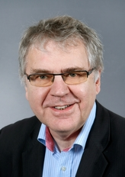

Steffen Jensen has been working with educational policy in the Danish Ministry of Education since 1983. He retired from his post as head of division in the ministry in 2016 and is now a private consultant with projects mainly in the educational sector.
Since 2003 Steffen has been head of the division for guidance in the ministry and in that capacity he has been responsible for the implementation and development of the Danish educational guidance system. He was member of the European Commission’s expert group om guidance and from 2007 of ELGPN (The European Lifelong Guidance Policy Network).
Prior to his work in the guidance field Steffen was head of divisions on statistics, economy and information technology. He began his career in the ministry as inspector general of upper secondary education.
After his graduation for the University of Copenhagen in mathematics and physics he worked as a teacher in these subjects in an upper secondary school.

